**12 ATAR Physics**

**Quantum Physics & Light**

**Practical Test 2019**

**Name: Mark: $\frac{}{\text{39}}$**

**BACKGROUND**

When gases are placed in a tube and subjected to a high-voltage electric discharge, the electrons in the atoms can be excited to higher energy levels within the atoms; when they return to their original levels electromagnetic radiation is emitted. Some of this radiation may be in a wavelength region that is visible to the human eye.

To measure these wavelengths in the laboratory, we must first separate them. To the naked eye, the various wavelengths (colours) of light emitted by an element are mixed together and appear as a single colour that is a combination of the component colours. If we view the light through a diffraction grating, however, the individual wavelengths are separated.

A diffraction grating is a piece of glass or clear plastic with many very narrow and closely spaced lines on it. As the light emerges after being diffracted by the grating, these tiny lines cause the diffracted light to interfere with itself in such a way that the different wavelengths of the light to appear in different positions to the left and right of the original direction in which the light was traveling. See the figure below.

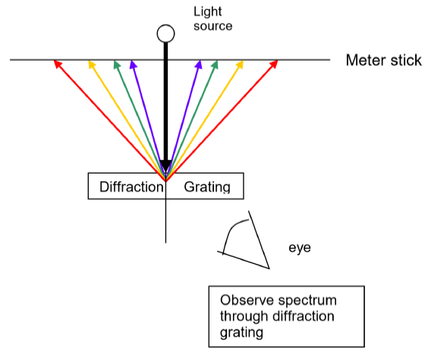

In this experiment, mercury is placed in an electric discharge tube and a high voltage is placed across the tube. The excited mercury emission looks almost white, but it is in reality composed of a number of different colours or wavelengths of visible light. You will use a diffraction grating to allow you to separate the different wavelengths in the visible region. The position of these lines will be measured. There is also some emission in the ultraviolet region, but the human eye can’t see it.

After using the mercury data, you will then examine the spectrum of helium and calculate the wavelengths of the visible part of this spectrum.

**Part A** **Collecting the data** Group Members: ________________________

**AIM:** To measure the position of the emission spectrum lines of mercury vapour and helium.

**APPARATUS:** Lamp holder and high voltage power supply

Hg and He discharge lamp

600 lines/mm diffraction grating in a stand so that grating is at the same height as the centre of the Hg discharge lamp

2 x metre rulers

Thin pointer

**METHOD:**

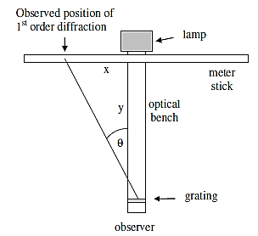

Figure 1. Experimental Setup for the Observation of Mercury Vapour Line Spectra

**Safety:** You should not look directly at the mercury discharge light coming from the slit in the mercury lamp. When you observe the spectra, **you will be looking at an angle to the lamp**, but you should not stare directly at the lamp.

Figure 1 illustrates the basic setup - use two metre rules to measure the distances *x* and *y*,

1. Set the metre rules on the bench. Be sure the two are exactly perpendicular to each other and that the bench rule is aligned at cross rule at the 50 cm mark.
2. Place the mercury lamp in the holder.
3. Put the grating on its support and place it about 75 cm from the mercury discharge tube. ***Record the position y.*** The top of the grating is marked on the grating and it should be positioned so that the top is highest above the optical bench.
4. One lab partner will view the emission spectrum of mercury vapour by looking through the diffraction grating ***at an angle from one side*** and observing the yellow, green and violet lines at a position ***on the other side***of the mercury discharge lamp.
5. The other partner will stand behind the mercury discharge lamp and move a thin pointer along the meter stick to the position described by the observer. Record the position where the yellow, green or blue image appears in Table 1.
6. This procedure should be repeated for each of the yellow, green and violet lines by ***two***different students. Record this in Table 1.
7. Average the two *x* measurements of each spectral line by each observer.
8. Place the helium lamp in the holder. Repeat steps 4 to 6. Record this in Table 2.

**RESULTS:**

y = ……….. cm **[1 mark]**

**Table 1** Mercury vapour

|  |  |  |  |  |
| --- | --- | --- | --- | --- |
| **Line colour** | **Line wavelength**  **λ (nm)** | **x (cm)** | | |
|  |  | Observer 1 | Observer 2 | Average |
| yellow | 571 |  |  |  |
| green | 546 |  |  |  |
| violet/blue | 436 |  |  |  |

**[4 marks]**

**Table 2** Helium

|  |  |  |  |  |
| --- | --- | --- | --- | --- |
| **Line colour** | **Line wavelength**  **(nm)** | **x (cm)** | | |
|  |  | Observer 1 | Observer 2 | Average |
| red |  |  |  |  |
| yellow |  |  |  |  |
| green |  |  |  |  |
| violet/blue |  |  |  |  |

**[4 marks]**

**Part B** **Calibration of the emission spectrum of helium**

(Completed as an individual.)

**AIM:** To use the emission spectrum of mercury to calibrate the emission spectrum of helium.

**PROCESSING OF RESULTS:**

1. For the mercury vapour data, plot a graph of ***λ (nm)*** on the y-axis against

***average x (cm)*** on the x-axis.

Draw the line of best fit. **[5 marks]**



2. (a) Determine the gradient of the graph. Show your working clearly. **[3 marks]**

(b) Write the equation of the line of best fit. **[2 marks]**

………………………………………………………..

(c) Use the answers to Q 2 to calculate the wavelengths of the visible part of the helium spectrum and ***record these in Table 2***.

Show your working of ***ONE*** of the calculations in the space below. **[3 marks]**

**Working:**

**QUESTIONS**

1. Measurement of the position ***x*** of the mercury vapour emission lines was repeated for each of the yellow, green and violet lines by ***two*** different students.

(a) Why was the measurement repeated? **[1 mark]**

(b) Why was the measurement repeated by twodifferent students? **[2 marks]**

(c) Suggest another method that could be used to repeat the measurement.

[Hint: Consider page 1.] **[2 marks]**

2. What would be the effect on the position ***x*** of the mercury vapour emission lines if the diffraction grating was placed 100 cm from the lamp instead of 75 cm from the lamp? Explain. **[2 marks]**

3. The diagram below shows some of the possible electron energy levels in a hydrogen atom. The ionisation energy is 13.6 eV.



1. Explain what is meant by ionisation energy? **[1 mark]**

1. Indicate on the diagram where the electron would be if it were in “the ground state”. **[1 mark]**

(c) Light from a hydrogen discharge tube consists of a *line emission spectrum.*

Explain how line emission spectra are produced.

**[3 marks]**

(d) The only emission spectra which occur in the visible region are those involved with transitions to level 2.

Draw an arrow on the diagram to represent the transition for the longest wavelength photon emitted in the visible region. Calculate the energy difference in joules, for this transition if the longest wavelength of these in the visible region has a wavelength of 655 nm.

**[3 marks]**

4. The diagram below shows some of the energy levels inside a mercury atom. Assume the 10.4 ev is for the fourth energy level above groundstate and is below the ionisation energy.

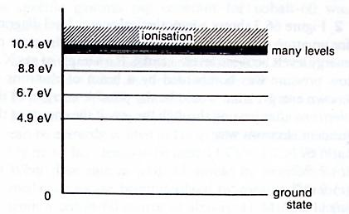

How many lines would you expect this atom to show in its:

(a) absorption spectrum  **[1 mark]**

(b) emission spectrum  **[1 mark]**